Billy and his Goat

**Astal** meets **Fez** (except replace the smart bird with a dumb goat, take out the 3D rotation and throw in a few aliens.)

Genre : 2D Action-Puzzle-Platformer.

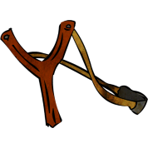Gameplay : Billy and his goat get sucked through a portal tucked somewhere in his families cornfield. They arrive on another world. Billy must help his goat make their way through the unfriendly environment and find a way back home. Billy can move, run, and jump through the level, unfortunately the goat cant. Billy must find ways to help the goat make it to the goal. Did I mention the goat is dumb? If left alone too long he tends to wander and may fall off a ledge. At least he helps occasionally by eating some shrub out of the way. All the while Billy must fight off aliens with his trusty Swiss army knife and slingshot.

Market Analysis : Mixing genres has become popular in both Triple A titles and indie games.

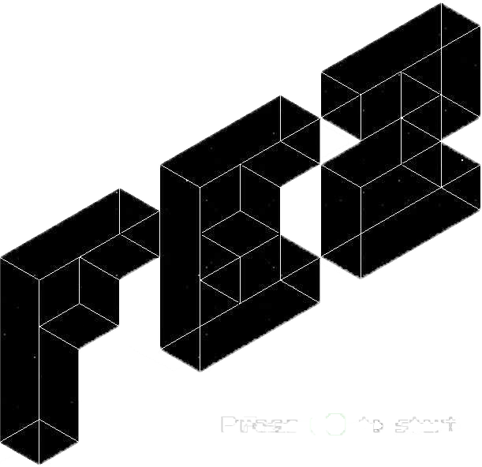is a fun example of a game with an animal companion. It is a definite keeper for those of us who actually bought a Sega Saturn. IGN staff writer, Levi Buchanan, ranked it amongst the top ten games on the Saturn. There were 597 titles for the Saturn.

is a game that shows that platformers still have a name in the game. It has been ranked one of the best games of its time even being put up against high budget games.

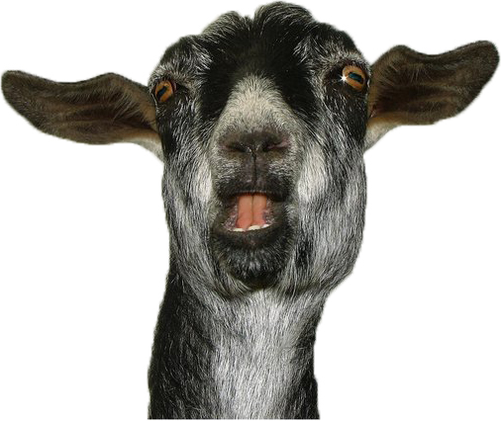

Most importantly in January of this year Fusion wrote a whole article on why goats are the Internets new cats.